

Measles Guidance for Schools

From Local Public Health in the Berkshires

This document is intended to provide guidance for schools on actions to take now, and in the event that

a case of measles is identified in your school building. Measles in schools can be serious to health and disruptive to learning. A single case of measles is a public health priority. Vaccination is the best protection against measles.

## **Massachusetts Regulations-**

According to the [MA Department of Public Health](https://www.mass.gov/doc/vaccine-preventable-disease-exclusion-guidelines-in-school-settings-0/download) pursuant to [105 CMR 220: Immunization of Students Before Admission to School](immunization-of-students-before-admission-to-school):

* Two (2) doses of live virus measles vaccine are required for all pupils in grades K – 12.
* Any child or adult in a school where a case of measles is identified who cannot show proof of two (2) properly administered measles vaccinations (or laboratory evidence of immunity or the disease) must be excluded from school attendance until such proof is provided.
* All those with 0 or 1 doses may avoid exclusion if they promptly receive a dose.

## **Actions for schools to take now-**

# Create a list of students and staff who do not have documentation of two (2) doses of MMR (measles mumps-rubella) vaccine.

This list includes students who have waivers or exemptions for medical, religious, and philosophical reasons. This group of students will need to be excluded if a case of measles occurs among a student or staff member in the school building. Exclusion means that students cannot come to school and cannot participate in any school activities or extracurricular events. Reach out directly to these families encourage vaccination, and provide education about state exclusion requirements the school must enforce if measles is identified within the school.

# Communicate broadly with all parents and staff reminding them of immunization recommendations.

The [Centers for Disease Control and Prevention recommendations](https://www.cdc.gov/vaccines/vpd/mmr/public/index.html#%3A~%3Atext%3DCDC%20recommends%20that%20people%20get%2Cdate%20on%20their%20MMR%20vaccination) for measles vaccination can be shared. Two doses of MMR vaccine are 97% effective preventing measles, and one dose is 93% effective preventing measles. Measles vaccines are available from a variety of sources, many of which are listed on [www.getvaccinatedberkshires.org](http://www.getvaccinatedberkshires.org), including:

* 1. Some primary care offices
  2. Local Pharmacies, including CVS, Walmart, Walgreens (check with locations based on child’s age)
  3. Your local BOH public health nursing program. To request assistance getting students or staff vaccinated, contact your health department public health nurse (see list at end of document).

# Promote respiratory hygiene and cough etiquette.

# Encourage frequent handwashing. If soap and water are not available, use hand sanitizer.

# Disinfect frequently touched surfaces such as doorknobs, tables, and counters.

# Encourage students and staff to stay home when sick.

# Review the signs and symptoms of measles.

# Be watchful for students who may come to school with fever and other signs and symptoms of measles.

Identify a private room for students suspected of having measles to wait while their parents are coming to pick them up from school. If measles is suspected, advise the family to call their healthcare provider ASAP. Ensure they know to notify the healthcare facility before they arrive that measles is suspected so that care can be taken to limit further spread. Families can call the BHS Nurse Hotline 855-855-2000.

1. **Report suspected measles cases,** immediately contact the Local Health Department public health nurse and the 24/7 Epidemiology Line at (617) 983-6800.

## **Actions to take immediately if a student or staff in your school building has measles-**

Quick actions can prevent further spread of measles to others at school and in the community.

# Communicate with Public Health, student families, and staff.

If you learn of any students or staff with confirmed or suspected measles in your school, immediately contact your public health nurse so that we can help ensure proper control measures are implemented. Public Health will work closely with your school to contact students and staff who may have been exposed to measles. If a case of measles is confirmed, the “[PRINCIPAL TO PARENT NOTIFICATION LETTER](https://publichealth.jhu.edu/sites/default/files/2024-08/principal-to-parent-notification-letter-sample-2-12-24-v2.pdf)” can be modified and shared by your school with students and their families.

# Isolation of measles positive individuals.

The student or staff member who is infected with measles must **isolate** – stay at home away from others and away from all public places, including daycare, school, work, social activities, sports, recreation events, all extracurricular activities, and public places like cinemas and shopping malls. Individuals who are in isolation must not be allowed in the school building until 4 days have passed since their rash began and they are physically able to return to school or work. While in isolation, individuals with measles or suspected measles must stay at home and away from others.

# Exclusion of students and staff without 2 documented doses of MMR.

**Exclusion** means a student or staff is not allowed to attend school or any extracurricular school activities such as childcare, clubs, and sports. All students in the school building without documentation of two doses of MMR must be excluded from school regardless of their personal exposure to measles or documentation of an exemption or waiver on file for a medical, religious, or philosophical reason. The school is required to communicate and enforce this exclusion. **If a case of measles is identified in your school, all children without documentation of two doses of measles vaccine are required to be immediately excluded from school.**

* 1. **Excluded students and staff with zero doses of measles vaccine-**
     + If the excluded student receives one documented dose of MMR within 72 hours after their initial exposure to measles at school, they may return to school immediately. A second dose of MMR will need to be received 28 days later to complete the 2-dose series.
     + Unvaccinated students (zero doses) who do not receive a dose of MMR within 72 hours (they refuse or are unable), including those who have a medical or other exemption to vaccination, must be excluded from school through 21 days after the onset of the last known case in the school building. It should be noted that if there are multiple cases of measles at a particular school, the student’s exclusion might be significantly extended beyond 21 days, since the 21-day time period would reset with the identification of each individual new case.
  2. **Excluded students and with one dose of measles vaccine-**
     + If the student receives a second documented dose of MMR at any time, they may return to school immediately upon school receipt of documentation of the second dose.
     + If documentation of a second dose of MMR vaccine is not received, exclusion from school continues through 21 days after the onset of the last known case in the school building.

It should be noted that if there are multiple cases of measles at a particular school, the student’s exclusion might be significantly extended beyond 21 days, since the 21-day time period would reset with the identification of each individual new case.

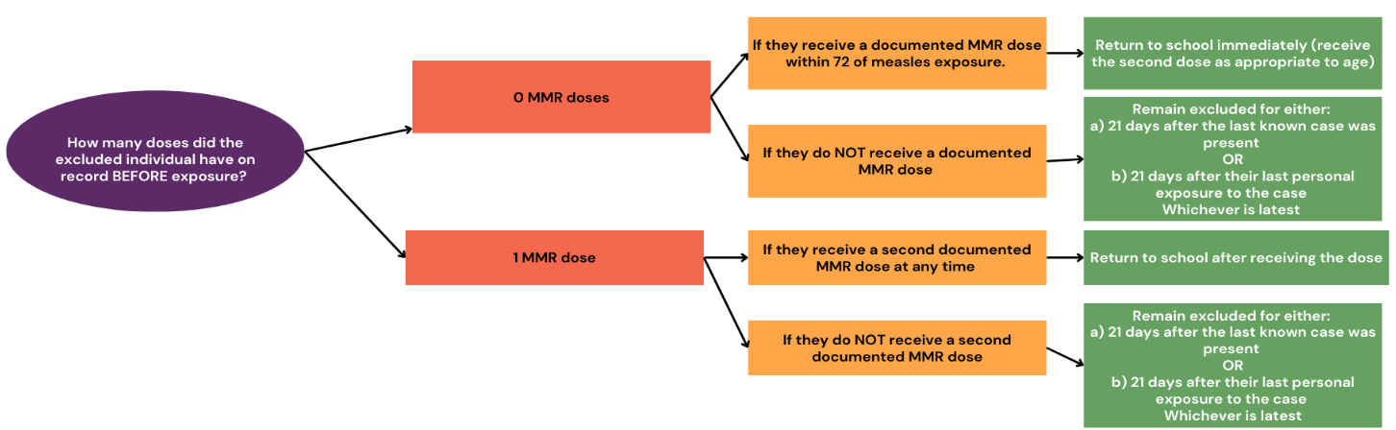

## **Exposed Students and Staff: Monitoring and Quarantine-**

# All exposed students and staff need to monitor for symptoms.

Exposure means sharing the same airspace as someone with measles. Students and staff who are identified as having been exposed to someone infected with measles, whether in the school building or elsewhere, will be advised by Public Health to monitor for signs and symptoms of measles for the next 21-28 days. Reminding families and staff to be vigilant in watching for signs of measles can help to identify new cases early and prevent further spread.

# Some exposed individuals will need to quarantine at home.

People who do not have proof of measles immunity may become sick after being exposed; they must quarantine so they do not infect others. **Quarantine** means staying at home, away from others, and away from all public places, including daycare, school, work, social activities, sports, recreation events, all extracurricular activities, and public places like cinemas and shopping malls. The need for home quarantine will depend upon exposure, age, documentation of immunity and health status of the exposed individual.

For information, see [Exposed to measles? What you need to know.](https://www.phdmc.org/agency/diseases/measles/2908-exposed-to-measles-what-you-need-to-know/file) Quarantine periods may range from 21-28 days or more Quarantine status will be reviewed, and dates of quarantine determined by Public Health.

## **Berkshire County Public Health Nurse Contact Information**

Berkshire Public Health Alliance Leslie Drager [ldrager@berkshireplanning.org](mailto:ldrager@berkshireplanning.org) (413) 822-6236

Pittsfield Health Department Patricia Tremblay [ptremblay@cityofpittsfield.org](mailto:ptremblay@cityofpittsfield.org) (413) 597-1586

So. Berkshire Health Collab. Jill Sweet [jill@tritownhealth.org](mailto:jill@tritownhealth.org) (413) 717 7209

## Measles Resources for Schools

**Public Health Nurses:**

* Berkshire Public Health Alliance Leslie Drager ldrager@berkshireplanning.org (413) 822-6236
* Pittsfield Health Department Patricia Tremblay ptremblay@cityofpittsfield.org (413) 597-1586
* So. Berkshire Health Collab. Jill Sweet jill@tritownhealth.org (413) 717 7209

**24/7 Epidemiology Line:** (617) 983-6800

**BHS Nurse Hotline (for families or public):** 855-855-2000

**Measles Resource List** (click [here](https://southernberkshirehealth.com/wp-content/uploads/2025/05/Measles-Resources-South-County.pdf) for most updated information)

<https://southernberkshirehealth.com/wp-content/uploads/2025/05/Measles-Resources-South-County.pdf>

